Editing Custom Notifications

CapHive enables customising the text of a range of notifications sent to the stakeholders.
To edit the same, you can access all the custom notifications set up for your account through the Notifications icon on the top right of the screen (the bell shaped one).
- Access the
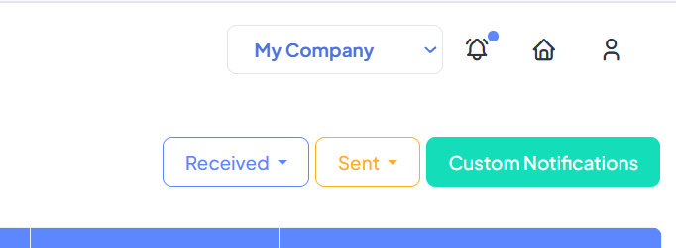

- Select the relevant notification by clicking on Show. In cacse you have multiple notifications, you can get to the one you need faster through using Filters (search on Tags, notification type, created on date etc).
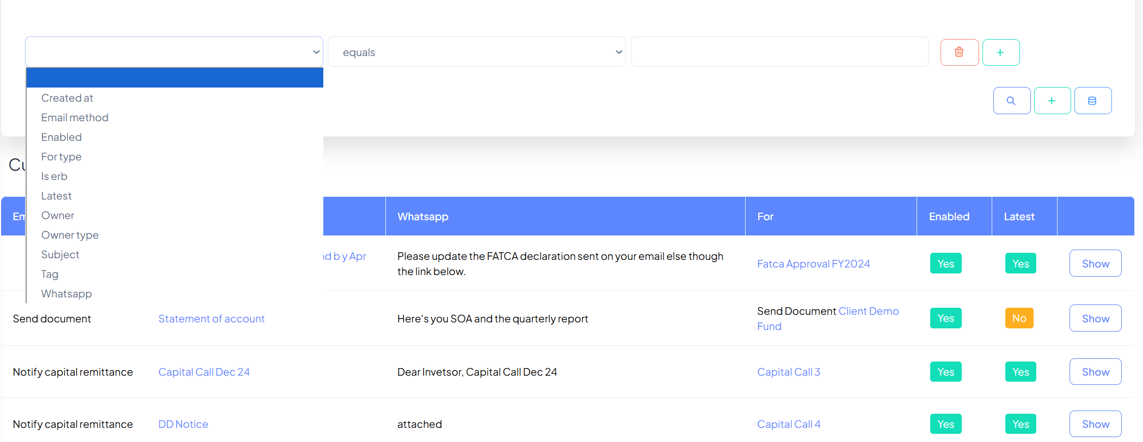

- Edit the text you need and press save.
In case there are advanced features such as dynamic fields set up, please do not edit these and request help from support@caphive.com for these advance use cases.

